Implementation of Missionaries and Cannibals Problem Using Python

Aim
To safely transfer all missionaries and cannibals from one side of the river to the other side.
Objective
- To move missionaries and cannibals across the river.
- To use a boat with limited capacity.
- To ensure missionaries are never outnumbered by cannibals on either side.
- To generate valid states.
- To reach the goal state safely.
Algorithm
- Start with all missionaries and cannibals on the left bank.
- Move one or two people using the boat.
- Check whether the resulting state is valid.
- Ensure missionaries are not outnumbered by cannibals on either bank.
- Generate all possible valid states.
- Continue moving people across the river.
- Check whether all missionaries and cannibals have reached the right bank.
- If the goal state is reached, display the solution.
- Stop the program.
PYTHON CODE:
from collections import deque

def is_valid(m, c):
if m < 0 or c < 0 or m > 3 or c > 3:
return False

if m > 0 and m < c:
return False

if (3 - m) > 0 and (3 - m) < (3 - c):
return False

return True

def missionaries_cannibals():
start = (3, 3, 1)
goal = (0, 0, 0)

queue = deque([start])
visited = set()

while queue:
state = queue.popleft()

if state == goal:
print("Goal Reached")
return

if state in visited:
continue

visited.add(state)

m, c, boat = state

moves = [(1,0), (2,0), (0,1), (0,2), (1,1)]

for dm, dc in moves:

if boat == 1:
new_state = (m-dm, c-dc, 0)
else:
new_state = (m+dm, c+dc, 1)

if is_valid(new_state[0], new_state[1]):
queue.append(new_state)
print(new_state)

missionaries_cannibals()

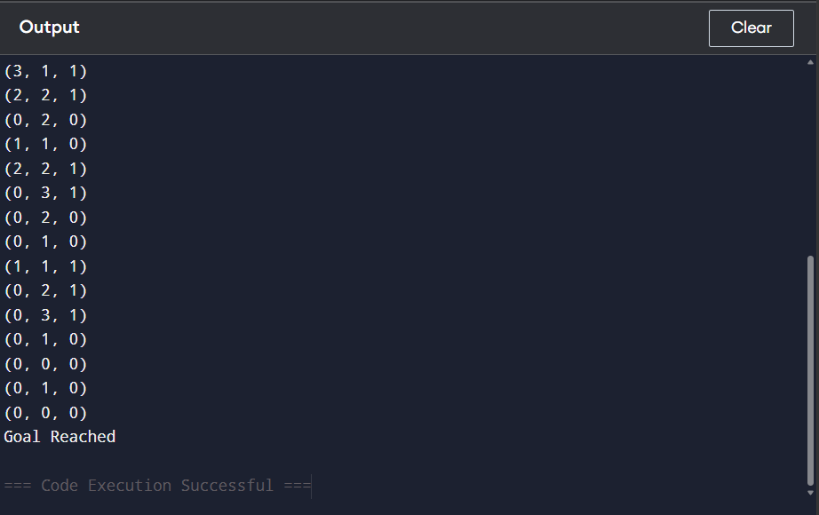
OUTPUT:

FLOW CHART:

Result
Thus, the Missionaries and Cannibals problem was successfully solved and all missionaries and cannibals were transferred safely to the opposite bank.

